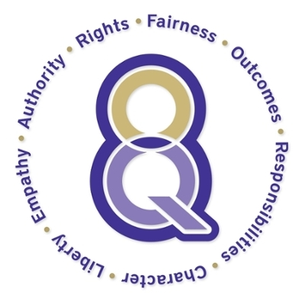

The Eight Key Questions reflect the best of humanity’s ethical reasoning traditions. The JMU people who conceived of the Ethical Reasoning in Action program operationalized these ethical reasoning traditions into a flexible and open framework to be used as prompts at the point of decision making. The questions, which can be voiced in first or second person and stated using culturally diverse content, highlight eight vital human values: fairness, outcomes, responsibilities, character, liberty, empathy, authority, and rights. These values may be expressed by different words, e.g. outcomes as “consequences,” “results,” “the future,” or “karma,” or in different languages, e.g. consecuencia (Spanish). Each names a distinctive—we believe cross-culturally common—ethical consideration.

Fairness - How can I act equitably and balance legitimate interests?
Outcomes - What achieves the best short- and long-term outcomes for me and all others?
Responsibilities - What duties and/or obligations apply?
Character - What action best reflects who I am and the person I want to become?
Liberty - How does respect for freedom, personal autonomy, or consent apply?
Empathy - What would I do if I cared deeply about those involved?
Authority - What do legitimate authorities (e.g. experts, law, my religion/god) expect of me?
Rights - What rights (e.g. innate, legal, social) apply?
School Board Scenario – Testing Trials
For this scenario, you and your group are sitting as members of the school board for Academy School District 12, deciding the fate of a high school teacher’s job. It is your responsibility to read through the file below and then discuss and vote on what action should be taken. Use the 8KQ to spark questions and justify your thoughts.

Harriet Byrd is a 9th grade social sciences teacher from Thompson High School. She has been accused of helping a student cheat on the World History SOL.
Testimony was given by several of her students that during the SOL test she pulled a specific student out of the room who was struggling to make progress on the test, leaving the rest of the students unsupervised for about 5 minutes. When she returned with the student the student was able to go back and work through his/her test with relative ease. The students also claim that this was not the first time something like this has happened. Those who testified feel as if Mrs. Byrd favors this particular student more so than others. They state this student receives special treatment on assignments, tests, and due dates. Students have brought this to their parents’ attention and the parents have emailed Mrs. Byrd on several occasions regarding this alleged bias. The teacher responded to many of the emails in the same fashion saying something along the lines of, “Thank you for your concern, but I strive to take care of all my students to the best of my ability. I will reassess and make sure that everyone is being treated equally and in a way that helps them best succeed.” The parents feel as if nothing is being done about this inappropriate behavior and they wish to see her contract be terminated effective immediately. Fearing that this allegation could affect the entire school and even the district for its credibility and accreditation in the coming year, the principal of Thompson HS has temporarily suspended her and filled her position with a long-term sub.
Harriet Byrd defended her actions by claiming that the student involved in the SOL test misconduct was struggling with an extremely unstable home life. According to Mrs. Byrd, the student is an only child and her mom is a single parent with two part time jobs, struggling to make ends meet. The student often carries an extra backpack home through the schools food program. These circumstances have been affecting her success at school. Mrs. Byrd has been trying to scaffold for and work with said student for the majority of the year. She admits that she has no evidence of this, but that this student has had suicidal thoughts in the past and has expressed this to Mrs. Byrd. Mrs. Byrd has reported this to the guidance counselors, but Mrs. Byrd also states that this student refuses to talk to them about anything going on at home, she only opens up to Mrs. Byrd. The teacher has been quoted saying, “I feel for this young girl. As a woman of color having been born to a lower-socioeconomic class and struggling with diagnosed depression and high levels of anxiety myself, I think Debra can open up to me because I understand her. I have been in her shoes and she needs to know that someone loves and cares for her.” On the day of the SOL Test, Mrs. Byrd testifies that the student was sobbing uncontrollably in her seat and she noticed that there was a large bruise on that student’s upper arm. She stated that she only took the student outside the testing area to question her about the bruise while also retaining a degree of privacy. The student claimed that it was nothing, just an injury she got after she tripped and fell against a table corner. Mrs. Byrd then reassured her she could get through this test and ushered her back into the room. Mrs. Byrd went ahead and reported the bruise to the guidance counselor later that day as suspected physical assault. According to the report, this investigation was dismissed. Mrs. Byrd also states that this trial has rocked her world and has increased her anxiety to dangerous levels. She requested that for the sake of her own mental health as well as for that of the student’s in question, she be allowed to return to the classroom and continue doing what she always has, helping students succeed.

